Name____________________________________ Date_______

U.S. History & Government ~ Miss Cummings James Monroe

What changes occurred during the presidency of James Monroe?
The conclusion of the War of 1812 brought about a feeling altogether different than what had previously existed in America. For the first time America had fought a war as a nation, united. The feeling that resulted from this unification of spirit marked a rise of nationalism and a shift in both foreign and domestic policy.
- The Presidency of James Monroe
  - How did America respond to the end of the War of 1812?
    - A strong sense of nationalism swept the country in the years following the War of 1812.
    - This period of increased nationalism and prosperity was called the Era of Good Feelings.
  - What measures did the nation take to further our prosperity?
    - Monroe developed the idea of the American System
      - This divided the United States into 3 sections.
        - An industrial North would turn out manufactured goods
        - Farmers in the South would provide agricultural products.
        - Farmers in the West would provide agricultural products.
      - The purpose of this was to develop self-sufficiency. Factory workers in the North would form a market for agricultural products. Farmers in the South and West would buy manufacture goods.
    - Congress passed protective tariffs: A tax on imports designed to protect domestic manufacturers.
      - Tariff Act of 1816--Congress adopted a mild protective tariff. Then in 1828, it significantly raised the tariffs.
    - Transportation Improvements were made.
      - National Road--Federal government authorized construction of a road from Maryland to Illinois, and also of canals so goods could move to market more easily.
    - Congress chartered the Second Bank of the United States to replace the first whose charter had expired.
      - To help the two sections of the country do business with each other; the federal government set up a new national bank.
      - Paper money quickly lost value because when the banks started to be regulated by the state banks, the banks issued a great deal of more paper money. This made it difficult to conduct business.
      - Second Bank of the United States-1816 Congress chartered this bank with 25 branches throughout the country.
      - The national bank issued its own paper money. These notes could be used anywhere, and by increasing the money supple they fueled a 2-year national business boom.
  - What actions did the Supreme Court take at this time?

The Supreme Court, under the leadership of Chief Justice John Marshall, supported the trend toward national power. This should come as no surprise considering he was one of the Federalist judges appointed by Adams. During his term, he dominated the court, writing more than half the opinions. Marshall’s decisions enlarged the power of the Supreme Court.
    - McCulloch vs. Maryland (1819)
      - Angered by the existence of the new Federal bank, the state of Maryland decided to tax the bank. McCulloch, a cashier for the bank refused to pay the tax claiming that a state had no power or right to tax the federal government.
      - The Supreme Court affirmed McCulloch's position. This precedent established the superiority of the federal government.
    - Gibbons vs. Ogden (1824)
      - Ogden held a New York State license allowing him to operate a ferry across the Hudson between New York and New Jersey. Gibbons received a Federal license and claimed that his license superseded that of Ogden.
      - The court ruled that Gibbon's federal license took precedence over that of Ogden because the federal government was given the power to regulate interstate trade.
  - How did President Monroe attempt to avoid involvement with Europe?
    - In 1823 President Monroe issued the Monroe Doctrine that warned all European powers not to interfere with affairs in the Western Hemisphere. They should not attempt to create new colonies or try to overthrow the newly independent republics.
    - The United States would consider such action “dangerous to our peace and safety.” At the same time, the United States would not involve itself in European affairs or interfere with existing colonies in the Western Hemisphere.
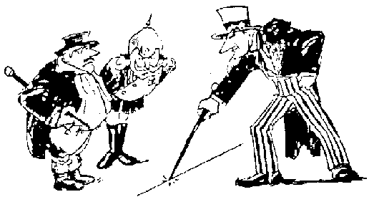
    - The doctrine was largely ignored because the United States lacked the power to enforce the doctrine. In the end it went unchallenged because European nation no longer desired new colonies in the region.
  - How did the nation seek to resolve the debate over the extension of slavery into the territories and new states?
    - In 1787 slavery had been prohibited in the Northwest Territory. However the issue was not considered yet for the Louisiana Purchase. When the Territory of Missouri applied for admission to the Union in 1819, its proposed state constitution recognized the right to hold slaves.
    - Congress was in chaos. For the first time, the merits of slavery were debated openly.
    - Missouri’s admission was stalled. Then Congress received an application from the area now known as Maine.
    - Missouri Compromise—Maine was admitted as a free state and Missouri as a slave state, which preserved the sectional balance in the Senate. The rest of the Louisiana Territory was split in two “spheres of interest”, one for the slave holders and one for free settlers. Those states above the 36'30" latitude line would become free and those below it would allow slaves.
    - President Monroe signed the Missouri Compromise in 1820. For a generation, the problem of slavery in federal territories seemed settled.

